**PRACTICUM REPORT**

Job sheet 4

Pseudocode dan Flowchart



RIDHO ANFA’AL

2341720222

CLASS 1I (INTERNATIONAL)

INFORMATICS ENGINEERING­­

INFORMATION TECHNOLOGY

STATE POLYTECHNIC OF MALANG

**Contents**

Experiment 1 3

Experiment 2 6

Experiment 3 8

Assignment 11

**Experiment 1 :**

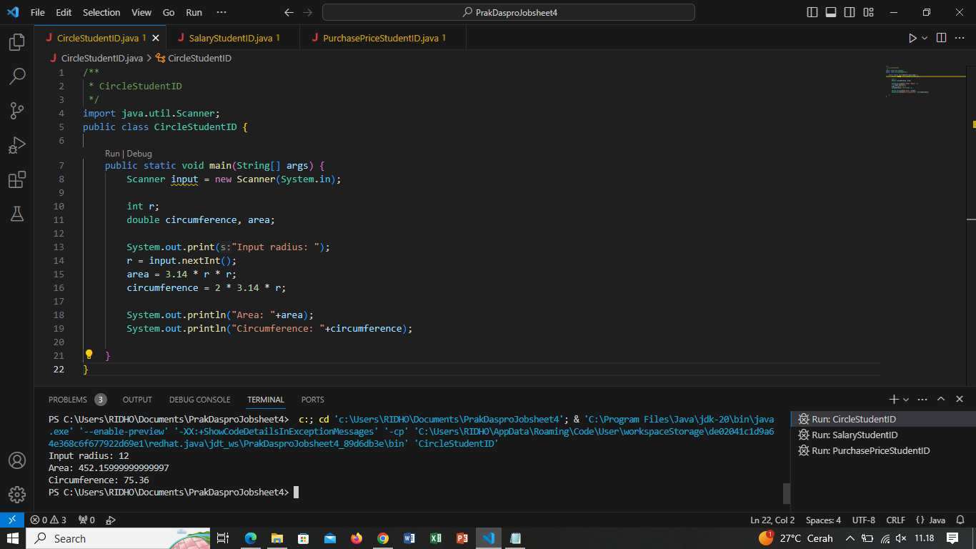

Questions

1. From experiment 1 above, modify the pseudocode by creating a new variable phi to

store 3.14. And in the circumference and area calculation, replace 3.14 by using phi

(use phi instead of 3.14 in the calculation).

Answer :

Algorithm: CircleStudentID

Declaration:

r : int

circumference, area, phi = 3.14 : double

Description:

1. print “Input radius!”

2. read r

3. circumference = 2*phi*r

4. area = phi*r*r

5. print circumference

6. print area

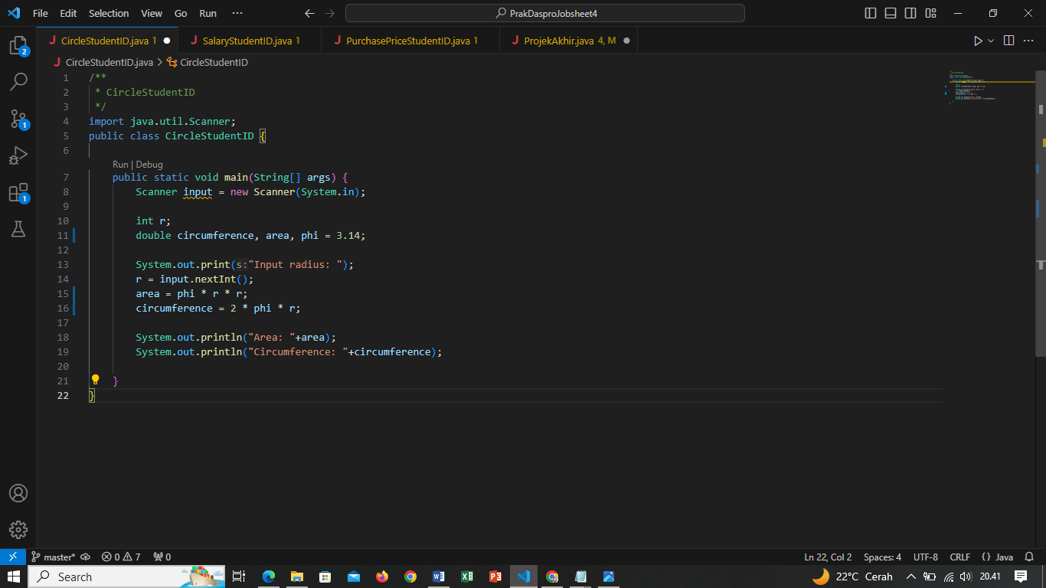

2. Create the flowchart from the modified pseudocode at question 1!

Answer :

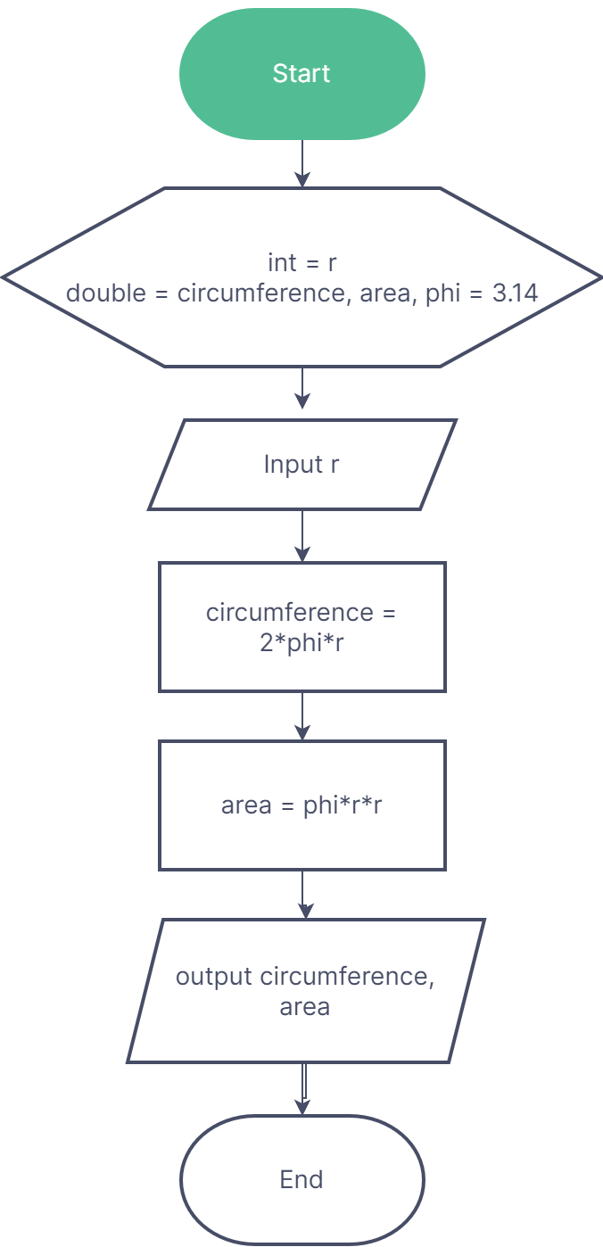

3. Implements the modified pseudocode/flowchart into a program (source code)!

Answer :



**Experiment 2 :**

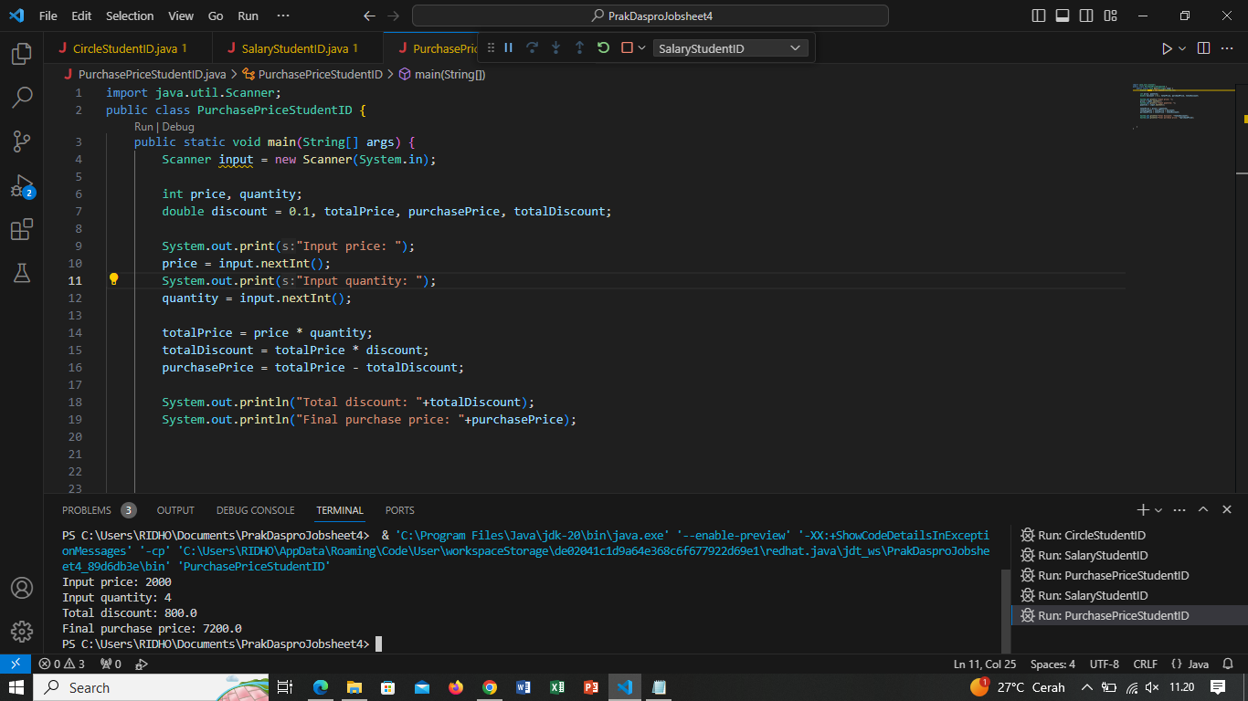

Question!

1. Create a pseudocode based on the above flowchart and modify it by getting the

salary and salaryDeduction from the user input!

Answer :

Algorithm : SalaryStudentID

Declaration :

numAttendance, numAbsence, totalSalary, salary, salaryDeduction : int

Description :

1. print "Input attendance number: "

2. read numAttendance

3. print "Input absence number: "

4. read numAbsence

5. print "Input salary: "

6. read salary

7. print "Input salary deduction: "

8. read salaryDeduction

9. totalSalary = (numAttendance*salary)-(numAbsence*salaryDeduction)

10. print "Total salary: "+totalSalary

2. Implement the modified pseudocode in the above question, into a java program!Answer :

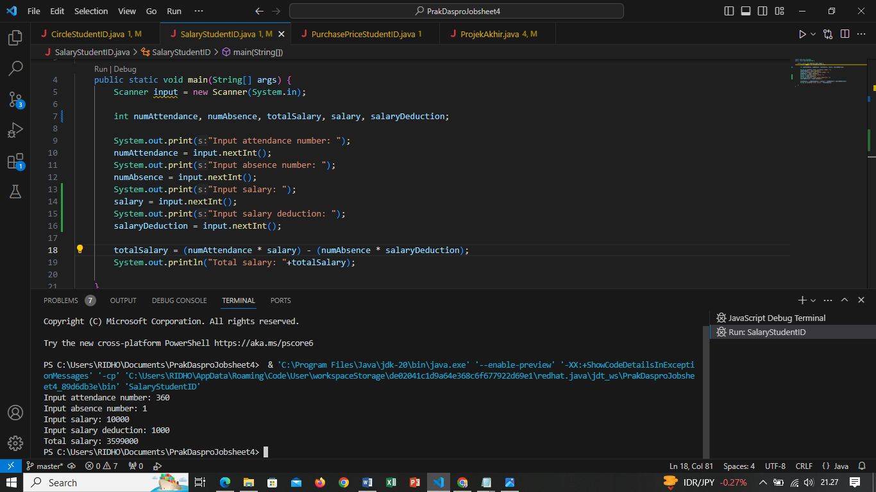

**Experiment 3 :**



Question!

1. Modify the pseudocode and flowchart above by adding user input for bookBrand and

pageCount, then change the discount to get the user input as well!

Answer :

Algorithm : NotebooksPurchasePriceStudentID

Declaration :

price, quantity, pageCount : int

bookBrand : String

discount, totalPrice, purchasePrice, totalDiscount : double

Description :

1. print "Input price!"

2. read price

3. print "Input quantity!"

4. read quantity

5. print "Input page count!"

6. read pageCount

7. print "Input book brand!"

8. read bookBrand

9. print "Input discount!"

10. read discount

11. totalPrice = price * quantity

12. totalDiscount = totalPrice * discount

13. purchasePrice = totalPrice - totalDiscount

14. print "The total discount is "

15. print totalDiscount

16. print "The Purchase Price is "

17. print purchasePrice

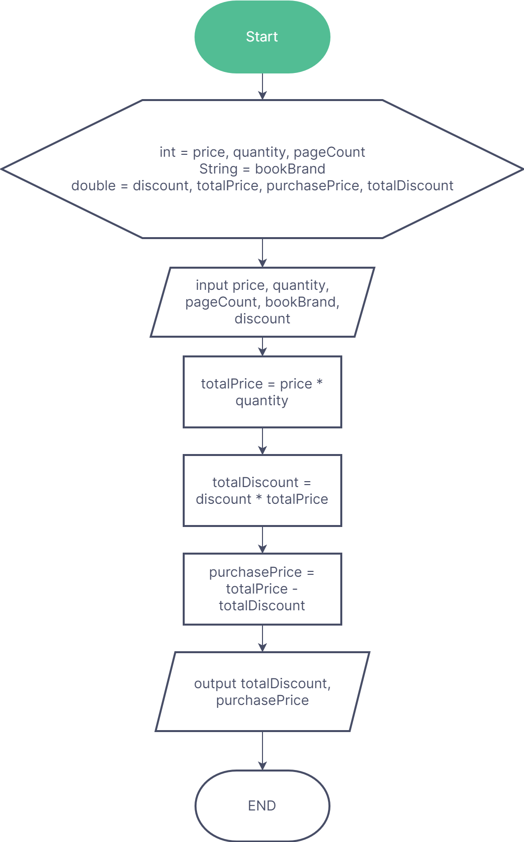

2. Implement the changes in a program!

Answer :

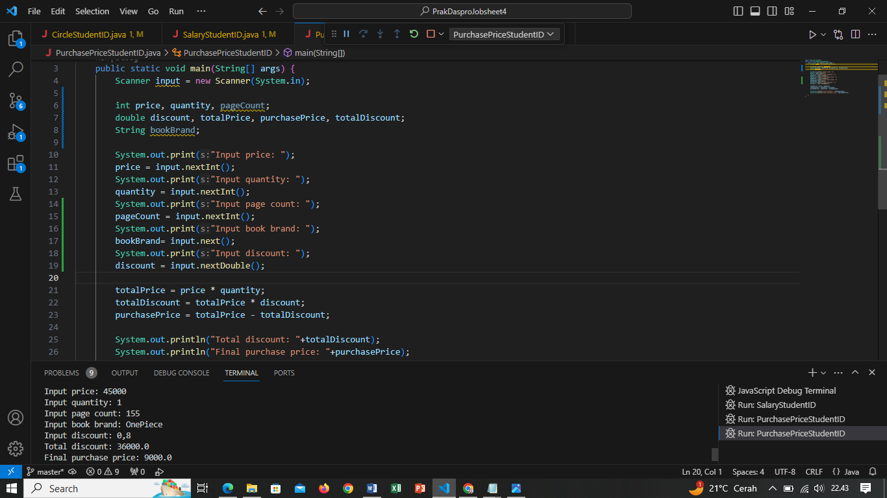

**Assignment :**

1. Create pseudocode based on your group project. The pseudocode that you create

can be identified from the processes (it could be input, output and arithmetic process

etc.)!

Answer :

Algorithm: Loan System

Declaration:

name, yes : String

interest, remainingBalance, monthlyInterest, monthlyInstallments, loanAmount : double

loanTerm : int

Description:

1. print "######### W E L C O M E to K R E D I T B A N K ##########"

2. print "Enter Full Name: "

3. read name

4. print "How much is your loan?: Rp."

5. read loanAmount

6. print "How many months is the payback time?: "

7. read loanTerm

8. print "Your balance amount: Rp."

9. read remainingBalance

10. monthlyInterest = remainingBalance*interest

11. print "Your monthly interest: Rp."+monthlyInterest

12. monthlyInstallments = loanAmount/loanTerm+monthlyInterest

13. print "Your monthly installment: Rp."

14. print "Would you be willing to pay? "

15. read yes

16. print "\t LOAN REQUEST HAS BEEN APPROVED"

17. print "\t###### T H A N K Y O U ######"

2. From the answer to question 1, please create the flowchart for each pseudocode

that is already created!

Answer :

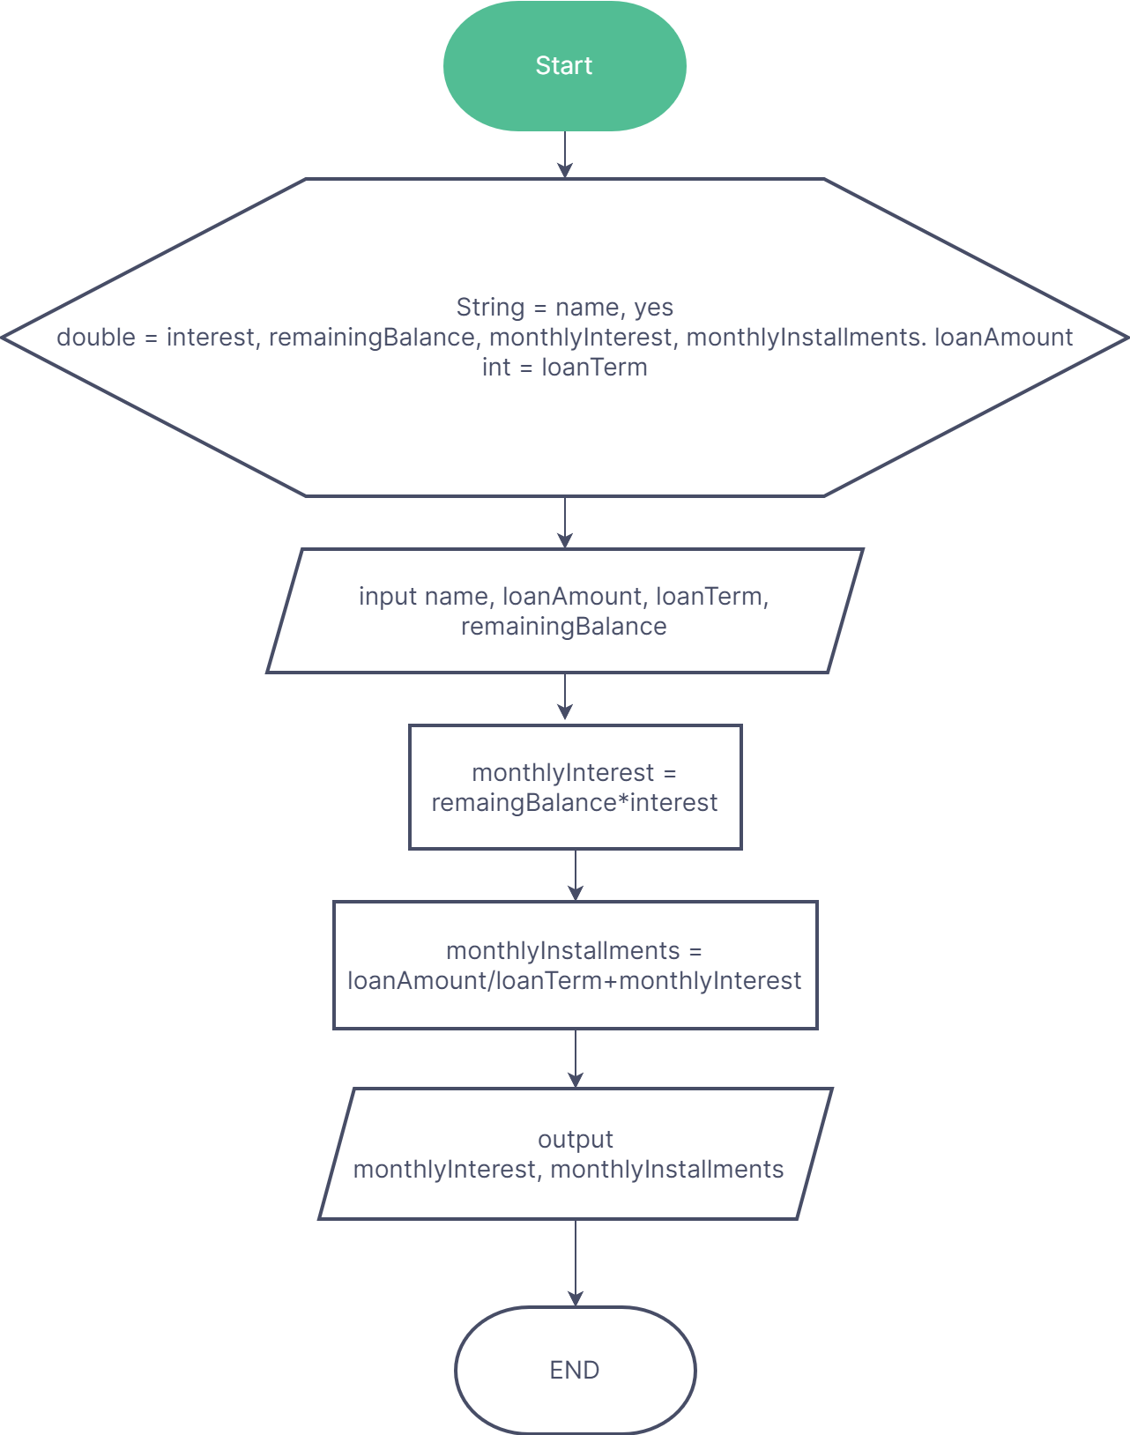

3. Implement the pseudocode/flowchart into a program. Please make a note that the

program will only include input, output, variable declarations, arithmetic operation

(and any other operator). Since we haven’t reached condition selection, looping,

method, array, then you do not have to use it right now.

Answer :

